**Part 1: Ideation**

1. **Description: Martha Berry Madness**

*Martha Berry Madness* is an adventure game where the main character is set out on a quest to avenge the infamous Martha Berry who was murdered. The student wakes up and will find that a ghost has chosen to appear to them! This is the ghost of Martha Berry who was brutally murdered in a hostile administrative takeover of the school. The main character must find clues and fight the administration who is trying to stop him to determine who has benefited from the crime and then avenge Martha Berry.

1. **References:**

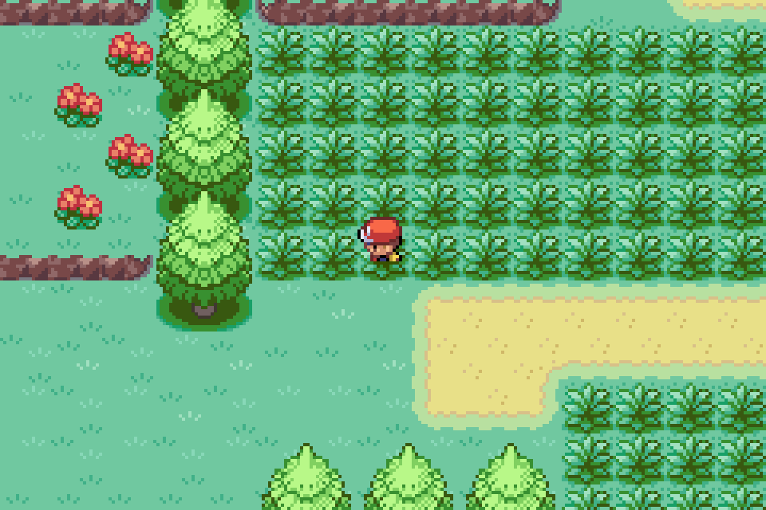

**Pokémon: Leaf Green** is a top-down adventure game in which the player has to assemble their very best team of Pokémon, wild creatures with fantastic abilitiesthat can bond with their human captures. After assembling the team, the player must train them to be as strong as possible so that they can defeat the evil team rocket and eventually beat the elite four to become the strongest trainer in the region. The aesthetics of this game will be heavily influenced in my game, if possible, with the scope I would also really enjoy “companion-based battles” like Pokémon has.

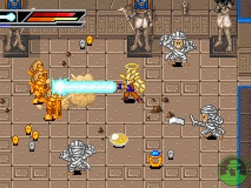

**Dragon Ball Z: Buu’s Fury** is another top-down adventure game in which the player plays as multiple characters to accomplish the story’s goal of defeating the evil “Buu” who is trying to destroy the earth. Your characters level up as they defeat more enemies, and I would really like to add this to my game so that there is a reward for fighting enemies and not running away. Furthermore, the characters all have multiple attacks in which they can alternate through but have a limited amount of stamina in which to perform these attacks.

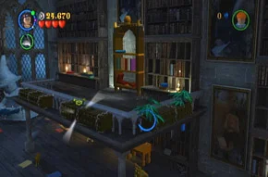

**Lego Harry Potter** is an adventure style game in which the player follows the story line of the famous Harry Potter books but has more fun because its Lego themed. There is one subplot of this game where you are navigating around the library, but it is after curfew hours so you have to hide from the teachers while looking for a very important book. I would really like to incorporate a level where you are hiding like this in my game.

1. **Reference images:**

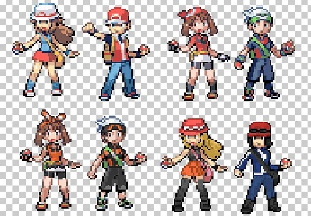Main Character <https://www.google.com/url?sa=i&url=https%3A%2F%2Fimgbin.com%2Fpng%2F2DXKfX8z%2Fpok%25C3%25A9mon-ruby-and-sapphire-pok%25C3%25A9mon-firered-and-leafgreen-pok%25C3%25A9mon-gold-and-silver-pok%25C3%25A9mon-x-and-y-png&psig=AOvVaw2m8bbED_1w-bEoJjvDkym2&ust=1616716932073000&source=images&cd=vfe&ved=0CA0QjhxqFwoTCODC4oiSyu8CFQAAAAAdAAAAABAD>

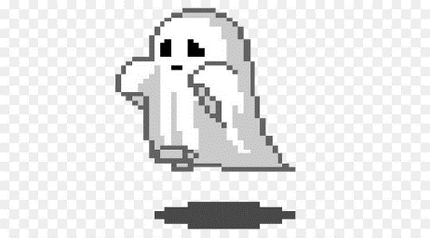Martha Berry’s Ghost <https://www.google.com/url?sa=i&url=https%3A%2F%2Fwww.cleanpng.com%2Fpng-pixel-art-animated-film-ghost-2224466%2F&psig=AOvVaw0GDRCiY8n72wS3jbWYpLmQ&ust=1616717545010000&source=images&cd=vfe&ved=0CA0QjhxqFwoTCMj1kbSUyu8CFQAAAAAdAAAAABAD>

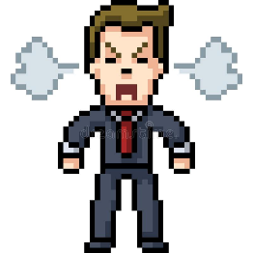Administrative Thug <https://www.google.com/url?sa=i&url=https%3A%2F%2Fwww.dreamstime.com%2Fillustration%2Fpixel-art-man-suit.html&psig=AOvVaw3QhpVYEabdLfwEdzjUDxlO&ust=1616717634259000&source=images&cd=vfe&ved=0CA0QjhxqFwoTCKCjrNaUyu8CFQAAAAAdAAAAABAD>

1. Plating area (see attached pdf)
2. Controller interactions

X joystick: moves hero horizontally across the screen

Y joystick: moves hero vertically across the screen

Button A: interacts with objects

Button B: uses temporary item

Button C: switches permanent items

Button D: uses permanent item